Delay
Delay is a simple effect with powerful applications. The basic delay plays back an audio signal after a specified delay time. Depending on the application, the delay time might range from a few samples to several seconds or longer.
Delay lines are the fundamental building blocks of many of the most important effects. They are rather easy to implement, and only small changes in how they are used allows many different audio effects to easily be constructed. In the simplest case, adding a single delayed copy of a sound to itself can enliven an instrument’s sound in a mix or, at longer delay times, allow a performer to play a duet with him or herself. Familiar effects, such as chorus, flanging, vibrato and reverb, are also built on delays.
In this chapter, we look at the DelayNode in the Web Audio API. We first discuss its use, including the parameters, and how it is implemented with delay lines. We next give three examples; simple summing of a source and a delayed copy to produce comb filtering, feedback delay based on routing the output of the delay node back to the input, implementation of a Vibrato effect by modulating a delay line with a low frequency oscillator, and the Karplus-Strong algorithm for producing the sound of a plucked string. The last example also demonstrates a limitation of the DelayNode when used in a feedback loop.

The DelayNode
The DelayNode is an AudioNode that implements a delay between input and output. It has a single input stream and single output stream, and the number of channels in the output stream always equals the number of channels in the input stream.
The delay node has two parameters.
- maxDelayTime: the maximum delay time for the node, in seconds. Note that this is set when the node is created, either with new DelayNode() or createDelay(), but not typically changed after creation. It has default value of 1, and must be less than 3 minutes.
- delayTime: the amount of delay (in seconds) to apply. The default delayTime is 0 seconds (no delay), and the maximum value is maxDelayTime . If the DelayNode is part of a feedback loop where the output connects back to input, then the value of the delayTime attribute is clamped to a minimum of one block of 128 samples.
Expressing the behavior mathematically, at each sample n, the output will be y(t) = x(t - d(t)) for an input signal x(t) and delayTime d(t).
By definition, a DelayNode introduces an audio processing latency equal to the amount of the delay. Also by definition, it can remain active (producing nonzero output) with zero input up to the maxDelayTime of the node.

The delay line
Delay is typically implemented using a delay line. Audio samples are stored in a pre-allocated memory buffer as they arrive, while previously stored samples are read from the buffer once the delay time has elapsed. In other words, in a simple delay, each sampling period includes one read operation (retrieving the delayed signal) and one write operation (storing the current signal). When the end of the memory buffer is reached, the system should loop around to the beginning of the buffer. In signal processing, this process of looping around the buffer is known as a circular buffer and it is quite efficient
The DelayNode has a delay line, which is an internal buffer that holds delayTime seconds of audio. The processing involves writing to the delay line, and reading from the delay line. This is done via two AudioNodes that are internal to the DelayNode and not exposed. A DelayWriter writes the input audio into the internal buffer. It has the same input connections as the DelayNode that uses it. A DelayReader is a source node that reads the audio data from the internal buffer. When producing an output buffer, the DelayReader gives the audio that was written to the DelayWriter delayTime seconds ago. It is connected to the same AudioNodes as the DelayNode it was created from. It is implemented with a circular buffer so that each sampling period, only one element of the buffer array is changed; the oldest sample in the buffer is overwritten with the new sample from the DelayWriter. For more details on how circular buffers are used, see Chapter 19.

Delay line interpolation
An immediate problem arises. Delays are implemented using a buffer of discrete audio samples. To change the delay time, we change the distance in the buffer between where samples are written and where they are read back.
However, we often want to delay the signal by an amount that does not fall exactly on a previous sample. For instance, many effects, including the flanger and chorus, require a delay that changes over time. To achieve a smooth variation in delay, rounding to the nearest integer number of samples is usually not good enough.
Delay becomes more complex when a non-integer number of samples is required. For instance, we might vary the delay of a signal using an oscillator to produce a vibrato effect,
$$y\left[n\right]=x\left[n-α(1+sin(2πnf/f_{s}))\right]$$
Here, α is the width of the delay modulation, f is the modulation frequency and f_{s} is the sampling rate. But x[n] is only defined for integer n. So for instance, x[0.5] does not exist. Strictly speaking, it is not correct to think of x[0.5] as “halfway between” x[0] and x[1]. However we might ask what the result would be if x[n] was converted from discrete to continuous time, shifted half a sampling period, then re-converted to discrete time.
In practice, fractional delays in audio are implemented using interpolation, in which a weighted combination of surrounding samples is used to approximate the fractional sample value. Interpolation involves estimating a value of a continuous function, given discrete points, and can be used to estimate values between points on a delay line. Polynomial interpolation is where the function is estimated to be an N^{th} order polynomial, y(t)= c_{N}t^{N}+ c_{N-1}t^{N-1}+… c₁t¹+ c₀.
If values out of the delay line closest to the required point are read, this is zeroeth order, or nearest neighbor, interpolation. It is probably the least computationally expensive approach. However, the output now has abrupt jumps between values. The quality of this approach is quite poor. Clicking in the output may be heard as the delay length changes, also known as "zipper noise."
Linear interpolation, or first order interpolation, is implemented by connecting two successive samples by a straight line, and then reading the desired value from that line. This is given in the following equation,
$x(t)=(n+1-t)x[n]+(t-n)x[n+1], n≤t<n+1$.
The nearest neighbors are usually used, so that n is the largest integer less than or equal to t.
Linear interpolation is simple to calculate and produces much better results than nearest-neighbor interpolation. However, it is still only a rough approximation to the ideal continuous time case, and it can introduce noise and aliasing into the signal. In many cases, audibly better quality will be obtained with a more computationally-complex interpolation method, such as quadratic or cubic interpolation, which use more neighbors to better estimate the shape of the curve x(t) in the neighborhood of x[n] (Reiss & McPherson, 2014).
The Web Audio API does not specify the kind of interpolation to use for fractional delay. However, linear interpolation is used in the WaveshaperNode and in parameter automation (setValueCurveAtTime), so it is likely that most implementations would also employ it here.

Example – comb filter
Some interesting effects occur if one just sums an input signal with a delayed version of that input. We can do some mathematical analysis to see how this operation affects the frequency content of a signal.
For an input signal x[n] and a delay of D, the output is just $y[n]=x[n]+x[n-D]$.
Taking the Z transform, we can find the frequency-domain transfer function:
$$Y\left(z\right)=\left(1+z^{-D}\right)X\left(z\right) \\ H\left(z\right)=\frac{Y\left(z\right)}{X\left(z\right)}=1+z^{-D} \\ {\left|H\left(z\right)\right|}^{2}=\left(1+z^{-D}\right)\left(1+z^{D}\right)=2\left(1+cos(2πfD)\right)$$
This is 0 whenever $cos(2πfD)=-1$ , or $f=D/2, 3D/2, 5D/2,...$
The magnitude response is shown in Figure 10.1, for D = 1 millisecond. There are notches in the response that extend all the way to $-∞$ dB, and occur at 500 Hz, 1500 Hz, 2500 Hz, etc. This is known as a comb filter, since when plotted with linear frequency, the notches resemble the teeth of a comb as used for your hair.
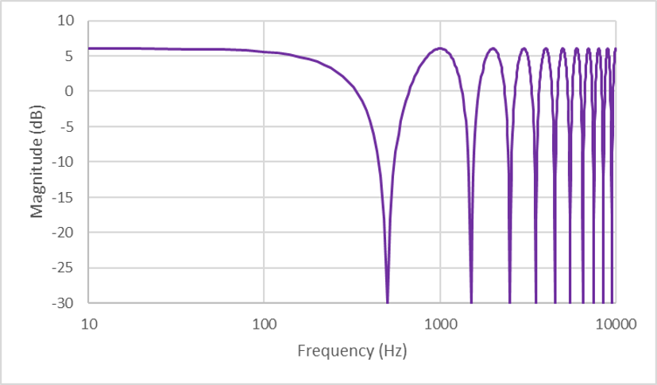
Figure 10.1. Magnitude response of a comb filter using 1 millisecond delay.
Code for a comb filter is given in Code example 10.1. The comb filter is implemented simply by sending both a source and a delayed copy of that source to the destination. The source is an oscillator. Here, we used the input type number, to give the user fine control over the oscillator’s frequency and the delay time. By choosing, for instance, delay of 1 ms and frequency of 1500 Hz, one can hear that the magnitude drops to 0, as expected from the magnitude response.
<p>Frequency</p>
<input type='number' min=50 max=1000 value=440 step='any' id='Frequency'>
<p>Delay (ms)</p>
<input type='number' min=0.001 max=0.01 value=0.005 step=0.001 id='Delay'>
<input type='button' value='play' onclick='context.resume()' id='Play'>
<script>
var context = new AudioContext()
let tone = new OscillatorNode(context,{frequency:440})
let delay= new DelayNode(context,{delayTime:0.005})
tone.start()
tone.connect(delay)
tone.connect(context.destination)
delay.connect(context.destination)
Delay.oninput = () => delay.delayTime.value = Delay.value
Frequency.oninput = () => tone.frequency.value = Frequency.value
</script>

Code example 10.1. combFilter.html, implementing a comb filter using the delay node.

Example - Vibrato Simulation with a modulated delay line
Vibrato is a popular performance technique, defined as a small, quasi-periodic variation in the pitch of a tone. Vibrato can also be added to any audio signal as an audio effect.
Vibrato is characterised by its type of variation (the form of a periodic waveform), its frequency (how often the pitch changes) and width (total amount of pitch variation).
The vibrato effect works by changing the playback speed of sampled audio. Playing a sound faster raises its pitch, and playing it slower lowers the pitch. To add a vibrato, then, the playback speed needs to be periodically varied to be faster and slower than normal. This can be achieved by controlling the playback rate on buffered audio sources, but we would like to be able to add vibrato to any audio stream. Hence we will add vibrato through the use of modulated delay lines.
A modulated delay line is a delay line whose delay length changes over time. Delay alone will not introduce a pitch shift. If a constant delay is applied, the sound will be delayed but otherwise identical to the original. But now suppose that the delay decreases each sample by a constant amount Then less samples need to be played out to complete one period of a periodic waveform. So the playback rate increases. That periodic waveform appears to be shorter, and hence higher in frequency. Similarly, if the length of the delay line increases each sample, then a periodic waveform appears to be longer, and its frequency will be lowered.
In fact, the pitch shift depends on the time derivative of delay length (Reiss & McPherson, 2014). For a frequency component with frequency f_{c}, the new frequency after modulating the delay with a time varying delay $M\left(t\right)$, is:
$$f_{new}\left(t\right)=f_{c}\left(1-\frac{dM\left(t\right)}{dt}\right)$$To create a vibrato effect, then, the delay is periodically lengthened and shortened. That is, the delay length varies periodically around a fixed central value, producing periodic pitch modulation.
The vibrato effect is driven (making some parameters explicitly a function of time) with a Low Frequency Oscillator, or LFO.
Different LFO waveforms are preferred for different effects, but a sinusoidal LFO is typically used for vibrato. So the delay is given by,
$$M(t)=M_{avg}{+Wsin(}2πf_{LFO}t),$$
where M_{avg} is the average delay, chosen so that M(t) is always nonnegative. W is the width of the delay modulation and $f_{LFO}$ is the LFO frequency in Hz.
For a frequency component with frequency f_{c}, the new frequency after modulating the delay is:
$$f_{new}\left(t\right)=f_{c}\left(1-\frac{dM\left(t\right)}{dt}\right) \\ =f_{c}\left(1-W2πf_{LFO}cos(2πf_{LFO}t)\right)$$
This is very similar to the FM synthesis presented in Chapter 6. It shows that pitch shift depends on both W and f_{LFO}. For the same amount of delay modulation, a faster LFO will produce more pitch shift. This is an expected result, since increasing the frequency of a sine wave while maintaining its amplitude will result in a greater derivative. It also indicates the delay width that needs to be applied for a given vibrato depth D.
$W=D/(2πf_{LFO})$.
A code example of vibrato is given in Code example 10.2
<audio id='file' controls loop onplay='context.resume()'>
<source src='trumpet.wav'>
</audio>
<br>Vibrato Depth
<input type='range' min=0 max=0.05 value=0 step='any' id='Depth' oninput='Update()'>
<br>Vibrato Frequency
<input type='range' min=0.5 max=8 value=5 step='any' id='LFO_f' oninput='Update()'>

let context= new AudioContext()
let source = context.createMediaElementSource(file)
let delay= new DelayNode(context,{delayTime:0.5,maxDelayTime:10})
let LFOgain= new GainNode(context,{gain:0})
let LFO = new OscillatorNode(context,{frequency:2})
LFO.start()
source.connect(delay)
LFO.connect(LFOgain).connect(delay.delayTime)
delay.connect(context.destination)
function Update() {
LFO.frequency.value = LFO_F.value
LFOgain.gain.value = Depth.value / (2*Math.PI*LFO_F.value)
}
Code example 10.2. vibrato.html and vibrato.js, which implement a vibrato effect using a modulated delay line.
A MediaElementAudioSourceNode uses a MediaElement containing a recording of a few notes on a trumpet. This is connected to a DelayNode. Note that we set both a delayTime and maxDelayTime audio parameters, so that the calculated delay after modulation does not go negative or exceed the length of the delay line.
An LFO is created using an OscillatorNode. This LFO is connected to a gain node, so that the LFO is multiplied by the modulation width. This gain node then connects to the DelayNode's delayTime parameter.
All that is left is to be careful about choice of parameter values. The user can select a vibrato depth ranging from 0 (no vibrato) to 0.05 (an input frequency can be varied to plus or minus 5% of its original value). This is then translated to a modulation width using the formula above. Since the formula depends on the LFO frequency as well, changing the LFO frequency will also update the modulation width.

Example – feedback delay
Feedback delay sends a scaled copy of the delay output back to the input of the delay, as shown in Figure 10.2. Feedback causes the sound to repeat continuously, and assuming a feedback gain less than 1, the echoes will become quieter each time. Though the echoes are theoretically repeated forever, they will eventually become so quiet as to be below the ambient noise in the system and thus be inaudible.
Code example 10.3 shows the implementation of a basic delay with feedback. It implements the audio graph shown in Figure 10.2.
<p>Gain</p>
<input type='range' min=0.5 max=0.99 value=0.8 step='any' id='Gain'>
<p>Delay (ms)</p>
<input type='range' min=0.04 max=0.2 value=0.08 step='any' id='Delay'>
<input type='button' value='play' onclick='context.resume()' id='Play'>
<script>
var context = new AudioContext()
let tone = new OscillatorNode(context,{frequency:2000})
tone.start()
toneGain = new GainNode(context,{gain:0})
var delay= new DelayNode(context,{delayTime:0.08})
var feedback= new GainNode(context,{gain:0.8})
tone.connect(toneGain)
toneGain.connect(delay)
delay.connect(feedback)
feedback.connect(delay)
delay.connect(context.destination)
Delay.oninput = () => delay.delayTime.value = Delay.value
Gain.oninput = () => feedback.gain.value = Gain.value
Play.onclick = () => {
context.resume()
let now = context.currentTime
toneGain.gain.setValueAtTime(1, now)
toneGain.gain.linearRampToValueAtTime(0, now + 0.05)
}
</script>

Code example 10.3. feedbackDelay.html, which implements delay with feedback, and user control of the delay and feedback gain.

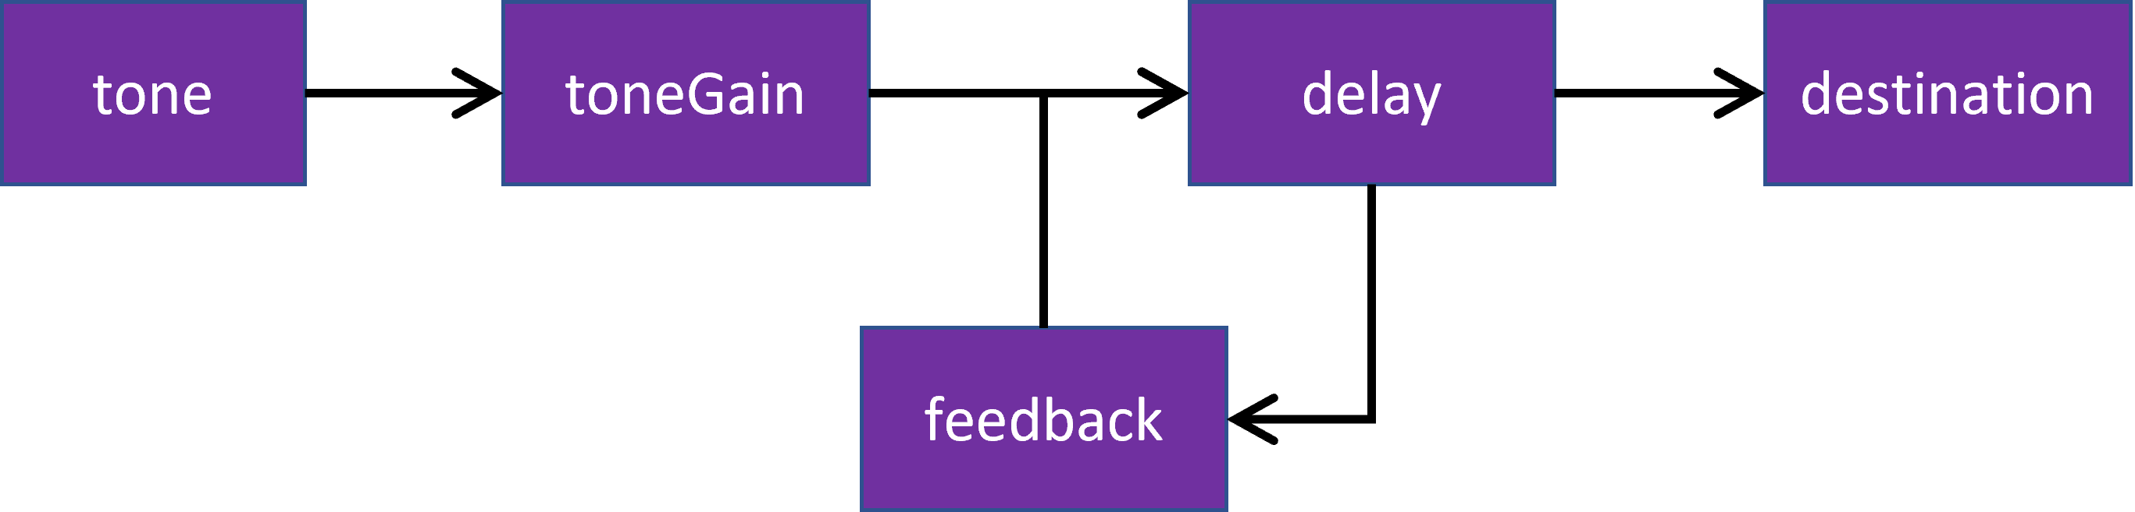
Figure 10.2. Audio graph for Code example 10.3.
A single burst of sound is created by having an oscillator produce a 2 kHz sinusoid, sent to a gain node. The gain is initially set to 0. When the button is clicked, it jumps to a gain value of 1 then ramps down to 0 over 50 milliseconds. This burst is what is sent to the feedback delay; which is implemented by circular routing, feeding an attenuated version of the output back to the input;
toneGain.connect(delay);
delay.connect(feedback);
feedback.connect(delay);
Care must be taken to ensure that the feedback gain is strictly less than one. The output of this feedback delay is then sent to the destination. So, when the button is clicked, the listener hears the tone burst, then a quieter version after the delay, a more quiet version after the delay time again, and so on until the delayed tone bursts become inaudible. The user is also given control over the two parameters that control the behavior of the feedback loop, the delayNode’s delay parameter, and the feedback gainNode’s gain parameter.

Example – the Karplus Strong algorithm
The Karplus-Strong algorithm is an early form of physical modelling synthesis, invented by Alex Strong, first analysed by Kevin Karplus, and then extended by David Jaffe and Julius O. Smith (Karplus & Strong, 1983) (Jaffe & Smith, 1983). As described by David Jaffe, he was playing violin in a string quartet and, “The violist was Alex Strong, who I didn't know. We just started talking and he was kind of a technical computer science-y kind of guy. I said something about how I was trying to synthesize guitars and he said, ‘Oh, you know, we just discovered this really great way of synthesizing guitars and I'd love to show it to you, but you have to sign a nondisclosure.’ And I said, ‘Okay, I'd love to do that.’”
In its basic form, the Karplus-Strong (KS for short) algorithm works by looping a short waveform through a filtered delay line. When the delay is very short, it can produce a sound similar to a plucked string. The delay
line acts like one period of the resultant sound.
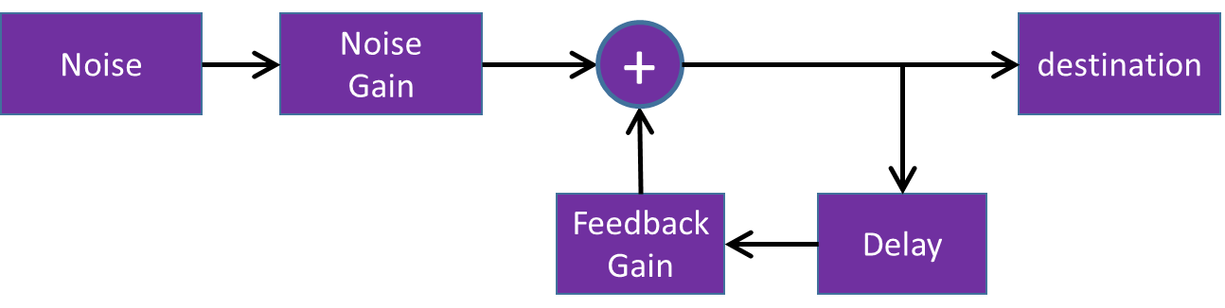
Figure 10.3. Audio graph for a simple implementation of the Karplus-Strong algorithm.

The short waveform is known as an excitation signal, and is typically a burst of noise. This excitation is simultaneously output and fed back into the delay line. The delay line is some L samples long, corresponding to producing a signal with fundamental frequency f_{s}/L. The output of the delay line is fed into a filter, which must have a gain less than 1 at all frequencies or else it will go unstable. This filter is typically a low order, low pass filter. The filtered output is then mixed back into the output and fed back into the delay line.
For simplicity’s sake, we’ll leave the filter out. The audio graph is given in Figure 10.3.
Implementing this with the web audio API requires a noise source, two gain nodes and a delay node. A simple implementation of the Karplus-Strong algorithm is given in Code example 10.4.
<p>Source</p>
<select id='Source'>
<option value='noise'>Noise</option>
<option value='sine'>Sine</option>
<option value='sawtooth'>Sawtooth</option>
<option value='triangle'>Triangle</option>
<option value='square'>Square</option>
</select>
<p>Decay</p>
<input type='range' min=0.8 max='0.999' value='0.9' step='any' id='Decay'>
<span id='DecayLabel'></span>
<p>Delay (ms)</p>
<input type='range' min=0 max=20 value=10 step='any' id='Delay'>
<span id='DelayLabel'></span>
<p>Width (ms)</p>
<input type='range' min=0 max='20' value=10 step='any' id='Width'>
<span id='WidthLabel'></span>
<p>Cut-off Frequency (Hz)</p>
<input type='range' min=0 max='10000' value='10000' step='any' id='Freq'>
<span id='Freq label'></span>
<p></p>
<input type='button' value='play' id='Play'>
<script src='KarplusStrong.js'></script>
var context = new AudioContext
let Noise = new AudioBufferSourceNode(context,{loop:true}),
NoiseGain = new GainNode(context,{gain:0}),
delay= new DelayNode(context,{delayTime:0.001}),
feedbackGain= new GainNode(context,{gain:0.8})
Noise.buffer = context.createBuffer(1,context.sampleRate,context.sampleRate)
for (i=0;i<context.sampleRate;i++)
Noise.buffer.getChannelData(0)[i] = 2*Math.random()-1
Noise.start()
Noise.connect(NoiseGain)
NoiseGain.connect(context.destination)
NoiseGain.connect(delay)
delay.connect(feedbackGain)
feedbackGain.connect(delay)
feedbackGain.connect(context.destination)
Decay.oninput = function() {
feedbackGain.gain.value=this.value
DecayLabel.innerHTML = this.value
}
Delay.oninput = function() {
delay.delayTime.value=0.001*this.value
DelayLabel.innerHTML = this.value
}
Width.oninput = function() { WidthLabel.innerHTML = this.value}
Play.onclick = function() {
context.resume()
let now = context.currentTime
NoiseGain.gain.setValueAtTime(0.5, now)
NoiseGain.gain.linearRampToValueAtTime(0, now + Width.value/1000)
}
Code example 10.4. KarplusStrong.html and KarplusStrong.js, showing a basic implementation of the Karplus-Strong algorithm using the delay node.
But as mentioned, delay nodes have a minimum of one frame (128 samples) of delay when they are used in any sort of feedback loop. So for a sample rate of 48,000, the highest frequency of a note produced using this algorithm is 48,000 / 128, or 375 Hz.

